Aim
To develop a web-based Library Management System to manage books, student borrowing, returns, fines, and study materials.
Algorithm
- Start the application.
- Allow admin and students to log in.
- Admin manages books, issues, returns, and fines.
- Students search books and download study materials.
- Display borrowing history and fine details.
- Stop the application.
Code
<!DOCTYPE html>
<html lang="en">
<head>
<meta charset="UTF-8">
<meta name="viewport" content="width=device-width, initial-scale=1.0">
<title>College Library Management System</title>

<style>
* {
margin: 0;
padding: 0;
box-sizing: border-box;
font-family: Arial, sans-serif;
}

body {
background: #f4f6f9;
color: #333;
}

header {
background: #243b55;
color: white;
padding: 20px;
text-align: center;
}

nav {
background: #141e30;
padding: 12px;
text-align: center;
}

nav a {
color: white;
text-decoration: none;
margin: 0 15px;
cursor: pointer;
}

nav a:hover {
color: #00d4ff;
}

.container {
width: 90%;
max-width: 1100px;
margin: 30px auto;
}

.section {
display: none;
}

.active {
display: block;
}

.hero {
background: white;
padding: 40px;
text-align: center;
border-radius: 10px;
box-shadow: 0 2px 10px #ccc;
}

.hero h2 {
color: #243b55;
margin-bottom: 15px;
}

.hero p {
margin-bottom: 20px;
}

button {
background: #243b55;
color: white;
border: none;
padding: 10px 18px;
border-radius: 5px;
cursor: pointer;
}

button:hover {
background: #141e30;
}

.cards {
display: grid;
grid-template-columns: repeat(auto-fit, minmax(200px, 1fr));
gap: 20px;
margin-top: 25px;
}

.card {
background: white;
padding: 25px;
border-radius: 10px;
text-align: center;
box-shadow: 0 2px 8px #ccc;
}

.card h3 {
margin-bottom: 10px;
color: #243b55;
}

form {
background: white;
padding: 25px;
border-radius: 10px;
box-shadow: 0 2px 8px #ccc;
max-width: 600px;
margin: auto;
}

input, select, textarea {
width: 100%;
padding: 11px;
margin: 8px 0 15px;
border: 1px solid #ccc;
border-radius: 5px;
}

table {
width: 100%;
border-collapse: collapse;
background: white;
margin-top: 20px;
}

th, td {
padding: 12px;
border: 1px solid #ddd;
text-align: center;
}

th {
background: #243b55;
color: white;
}

.search {
margin-bottom: 20px;
}

.fine {
color: red;
font-weight: bold;
}

footer {
background: #141e30;
color: white;
text-align: center;
padding: 20px;
margin-top: 40px;
}

h2 {
margin-bottom: 20px;
color: #243b55;
}
</style>
</head>

<body>

<header>
<h1>📚 College Library Management System</h1>
<p>Manage Books, Students, Materials and Fines</p>
</header>

<nav>
<a onclick="showSection('home')">Home</a>
<a onclick="showSection('books')">Search Books</a>
<a onclick="showSection('login')">Login</a>
<a onclick="showSection('admin')">Admin</a>
<a onclick="showSection('user')">Student</a>
<a onclick="showSection('materials')">Materials</a>
<a onclick="showSection('contact')">Contact</a>
</nav>

<div class="container">

<!-- HOME -->
<section id="home" class="section active">

<div class="hero">
<h2>Welcome to College Library</h2>

<p>
Search books, manage borrowing history, check fines,
and download academic materials easily.
</p>

<button onclick="showSection('books')">
Search Books
</button>
</div>

<div class="cards">

<div class="card">
<h3>📚 Books</h3>
<p>Search and view available books.</p>
</div>

<div class="card">
<h3>👨‍🎓 Students</h3>
<p>Manage student borrowing history.</p>
</div>

<div class="card">
<h3>💰 Fines</h3>
<p>Check pending library fines.</p>
</div>

<div class="card">
<h3>📄 Materials</h3>
<p>Download semester-wise materials.</p>
</div>

</div>

</section>

<!-- BOOK SEARCH -->
<section id="books" class="section">

<h2>Search Books</h2>

<input
type="text"
id="bookSearch"
class="search"
placeholder="Search by book name or author..."
onkeyup="searchBooks()"
>

<table id="bookTable">

<tr>
<th>Book ID</th>
<th>Book Name</th>
<th>Author</th>
<th>Year</th>
<th>Status</th>
</tr>

<tr>
<td>101</td>
<td>Artificial Intelligence</td>
<td>Stuart Russell</td>
<td>2024</td>
<td>Available</td>
</tr>

<tr>
<td>102</td>
<td>Machine Learning</td>
<td>Tom Mitchell</td>
<td>2023</td>
<td>Issued</td>
</tr>

<tr>
<td>103</td>
<td>Python Programming</td>
<td>Mark Lutz</td>
<td>2024</td>
<td>Available</td>
</tr>

<tr>
<td>104</td>
<td>Database Management</td>
<td>Raghu Ramakrishnan</td>
<td>2022</td>
<td>Available</td>
</tr>

</table>

</section>

<!-- LOGIN -->
<section id="login" class="section">

<h2>Login</h2>

<form onsubmit="login(event)">

<label>Email / Username</label>
<input type="text" id="username" required>

<label>Password</label>
<input type="password" id="password" required>

<label>Login As</label>

<select id="role">
<option value="student">Student</option>
<option value="admin">Librarian Admin</option>
</select>

<button type="submit">Login</button>

</form>

</section>

<!-- ADMIN -->
<section id="admin" class="section">

<h2>Librarian Admin Dashboard</h2>

<div class="cards">

<div class="card">
<h3>➕ Add Book</h3>
<p>Add new books to library.</p>
<button onclick="showSection('addbook')">
Add Book
</button>
</div>

<div class="card">
<h3>✏️ Manage Books</h3>
<p>Update or delete books.</p>
</div>

<div class="card">
<h3>📖 Issue Book</h3>
<p>Issue books to students.</p>
</div>

<div class="card">
<h3>↩️ Return Book</h3>
<p>Update returned book status.</p>
</div>

<div class="card">
<h3>💰 Fine</h3>
<p>Calculate student fines.</p>
</div>

<div class="card">
<h3>📄 Materials</h3>
<p>Upload semester materials.</p>
</div>

</div>

</section>

<!-- ADD BOOK -->
<section id="addbook" class="section">

<h2>Add New Book</h2>

<form onsubmit="addBook(event)">

<label>Book Name</label>
<input type="text" id="newBook" required>

<label>Author</label>
<input type="text" id="author" required>

<label>Publication Year</label>
<input type="number" id="year" required>

<button type="submit">
Add Book
</button>

</form>

</section>

<!-- STUDENT -->
<section id="user" class="section">

<h2>Student Dashboard</h2>

<div class="cards">

<div class="card">
<h3>🔎 Search Book</h3>
<p>Find required books.</p>

<button onclick="showSection('books')">
Search
</button>
</div>

<div class="card">
<h3>📚 Borrow History</h3>
<p>View issued and returned books.</p>

<button onclick="showSection('history')">
View History
</button>
</div>

<div class="card">
<h3>💰 My Fine</h3>
<p>Check pending fines.</p>

<button onclick="showSection('fine')">
Check Fine
</button>
</div>

<div class="card">
<h3>👤 My Profile</h3>
<p>View student profile.</p>

<button onclick="showSection('profile')">
Profile
</button>
</div>

</div>

</section>

<!-- BORROW HISTORY -->
<section id="history" class="section">

<h2>My Borrow History</h2>

<table>

<tr>
<th>Book Name</th>
<th>Issue Date</th>
<th>Expected Return</th>
<th>Status</th>
</tr>

<tr>
<td>Artificial Intelligence</td>
<td>01-09-2026</td>
<td>15-09-2026</td>
<td>Returned</td>
</tr>

<tr>
<td>Machine Learning</td>
<td>20-09-2026</td>
<td>04-10-2026</td>
<td>Not Returned</td>
</tr>

</table>

</section>

<!-- FINE -->
<section id="fine" class="section">

<h2>My Fine</h2>

<div class="card">

<h3>Current Fine</h3>

<p class="fine">₹50</p>

<br>

<p>
Fine for late return of Machine Learning book.
</p>

</div>

</section>

<!-- MATERIALS -->
<section id="materials" class="section">

<h2>Study Materials</h2>

<label>Year</label>

<select>
<option>1st Year</option>
<option>2nd Year</option>
<option>3rd Year</option>
<option>4th Year</option>
</select>

<label>Semester</label>

<select>
<option>Semester 1</option>
<option>Semester 2</option>
<option>Semester 3</option>
<option>Semester 4</option>
<option>Semester 5</option>
<option>Semester 6</option>
<option>Semester 7</option>
<option>Semester 8</option>
</select>

<table>

<tr>
<th>Material</th>
<th>Subject</th>
<th>Download</th>
</tr>

<tr>
<td>AI Notes</td>
<td>Artificial Intelligence</td>
<td>
<button onclick="downloadFile()">
Download
</button>
</td>
</tr>

<tr>
<td>ML Notes</td>
<td>Machine Learning</td>
<td>
<button onclick="downloadFile()">
Download
</button>
</td>
</tr>

</table>

</section>

<!-- PROFILE -->
<section id="profile" class="section">

<h2>My Profile</h2>

<form>

<label>Student Name</label>
<input type="text" value="Sandeep Reddy">

<label>Student ID</label>
<input type="text" value="STU101">

<label>Email</label>
<input type="email" value="student@gmail.com">

<label>Department</label>
<input type="text" value="Artificial Intelligence and Machine Learning">

<button type="button">
Update Profile
</button>

</form>

</section>

<!-- CONTACT -->
<section id="contact" class="section">

<h2>Contact Library</h2>

<form onsubmit="contact(event)">

<label>Name</label>
<input type="text" required>

<label>Email</label>
<input type="email" required>

<label>Message</label>
<textarea rows="5" required></textarea>

<button type="submit">
Send Message
</button>

</form>

</section>

</div>

<footer>
<p>© 2026 College Library Management System</p>
</footer>

<script>

// Change sections
function showSection(sectionId) {

let sections = document.querySelectorAll(".section");

sections.forEach(function(section) {
section.classList.remove("active");
});

document.getElementById(sectionId).classList.add("active");

window.scrollTo(0, 0);
}

// Search Books
function searchBooks() {

let input =
document.getElementById("bookSearch")
.value.toLowerCase();

let table =
document.getElementById("bookTable");

let rows = table.getElementsByTagName("tr");

for (let i = 1; i < rows.length; i++) {

let text =
rows[i].innerText.toLowerCase();

if (text.includes(input)) {
rows[i].style.display = "";
} else {
rows[i].style.display = "none";
}
}
}

// Login
function login(event) {

event.preventDefault();

let role =
document.getElementById("role").value;

if (role === "admin") {

alert("Admin Login Successful");

showSection("admin");

} else {

alert("Student Login Successful");

showSection("user");
}
}

// Add Book
function addBook(event) {

event.preventDefault();

let book =
document.getElementById("newBook").value;

alert(book + " added successfully!");

document.getElementById("newBook").value = "";
document.getElementById("author").value = "";
document.getElementById("year").value = "";
}

// Contact Form
function contact(event) {

event.preventDefault();

alert("Your message has been sent successfully!");
}

// Download
function downloadFile() {

alert("Material download started!");
}

</script>

</body>
</html>
Output:
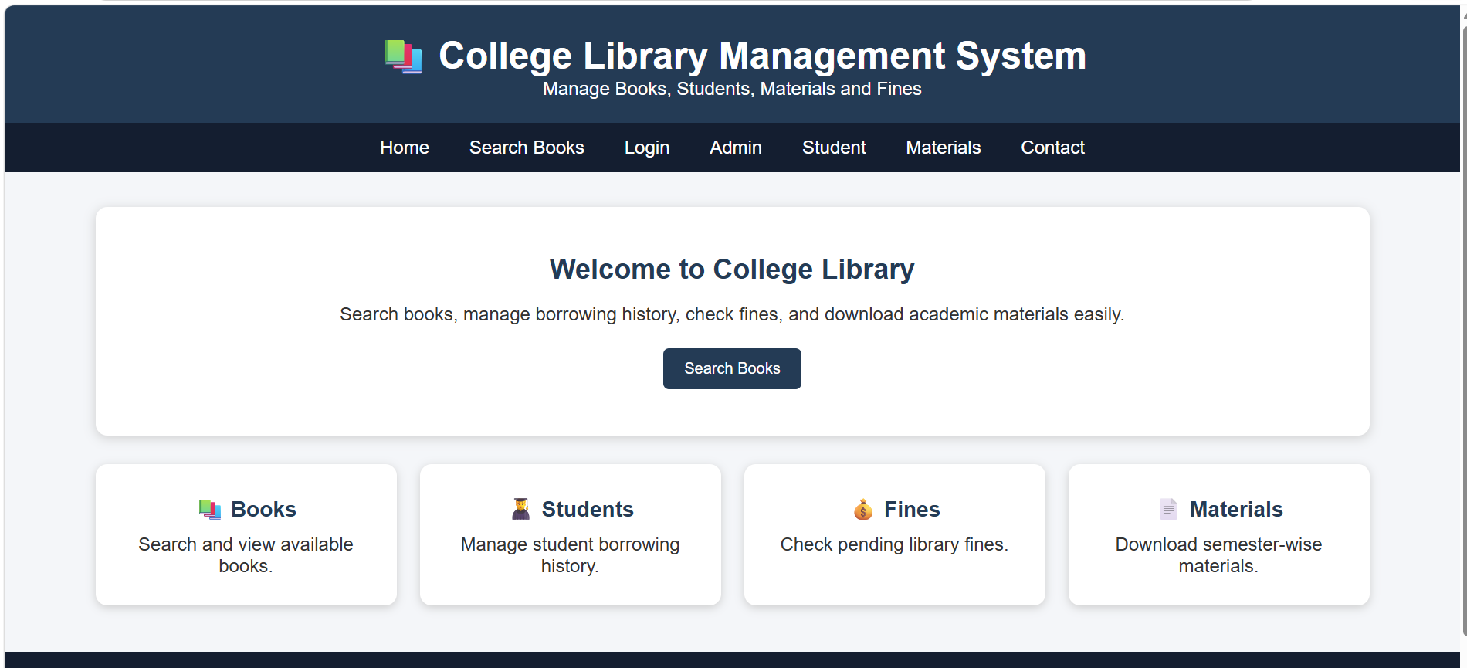
Result
The Library Management System helps students find books and materials easily and enables librarians to manage library operations efficiently.

